Name : Arjun Patel FRN: 006 ---- 7th nov batch combo java

Que 1:

#include<stdio.h>

#include<conio.h>

//convert time entered in hh mm sec into sec

int main(){

    int hr, min, sec, totalSecs;

    printf("Enter hour\n");

    scanf("%d", &hr);

    printf("Enter Min\n");

    scanf("%d", &min);

    printf("Enter Sec\n");

    scanf("%d", &sec);

    totalSecs = (hr\*3600) + (min\*60) + sec;

    printf("%d:%d:%d  --> %d seconds", hr, min, sec, totalSecs);

    return 0;

}

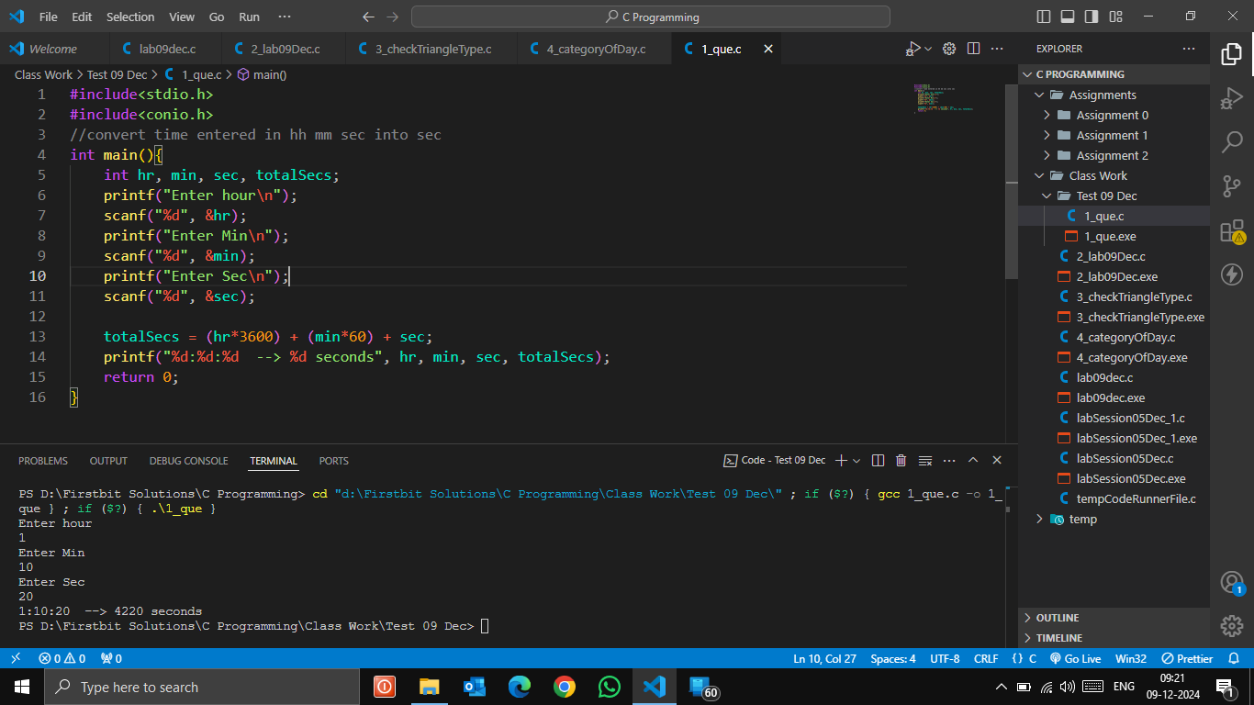

Que 2:

#include<stdio.h>

#include<conio.h>

int main(){

    int yr;

    printf("Enter year\n");

    scanf("%d", &yr);

    if(yr%4==0){

        if(yr%100!=0 && yr%400==0){

            printf("%d is not a leap year\n", yr);

        }

        else printf("%d is a leap year\n", yr);

    }

    else printf("%d is not a leap year\n", yr);

    return 0;

}

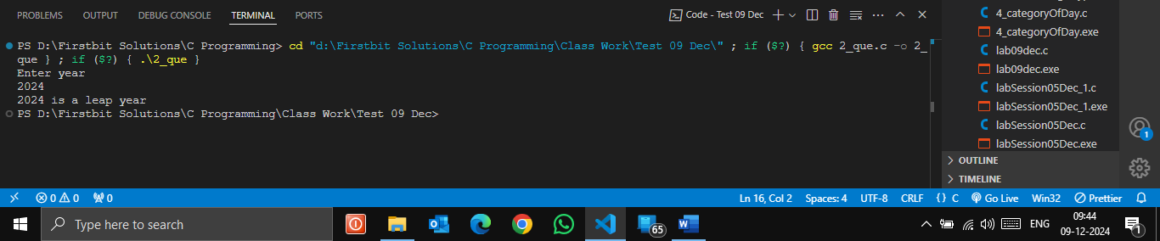

Que 3:

#include <stdio.h>

#include <conio.h>

// print last 2 digit of temp

// 223413 --> 13

int main()

{

    int num, temp;

    printf("Enter any number\n");

    scanf("%d", &num);

    temp = num;

    int ld = temp % 10; // 3

    temp = temp / 10;

    int sld = temp % 10; // 1

    int lastTwoDig = sld \* 10 + ld;

    if ((ld == 0 && sld == 0) || num == 0)

    {

        printf("Last 2 digits of %d is 00\n", num);

    }

    else

    {

        printf("Last 2 digits of %d is %d\n", num, lastTwoDig);

    }

    return 0;

}

